**Create a Table to store the data of the trigger.**

use production_db;

create table finance_update(before_update_assigned_budget int, updated_update_assigned_budget int,before_fi_phno int, updated_fi_phno int);

**BEFORE_INSERT Trigger**

CREATE DEFINER=`root`@`localhost` TRIGGER `production_db`.`finance_team_BEFORE_INSERT` BEFORE INSERT ON `finance_team` FOR EACH ROW

BEGIN

IF NEW.assigned_budget < 0 THEN

SET NEW.assigned_budget = 0;

END IF;

END

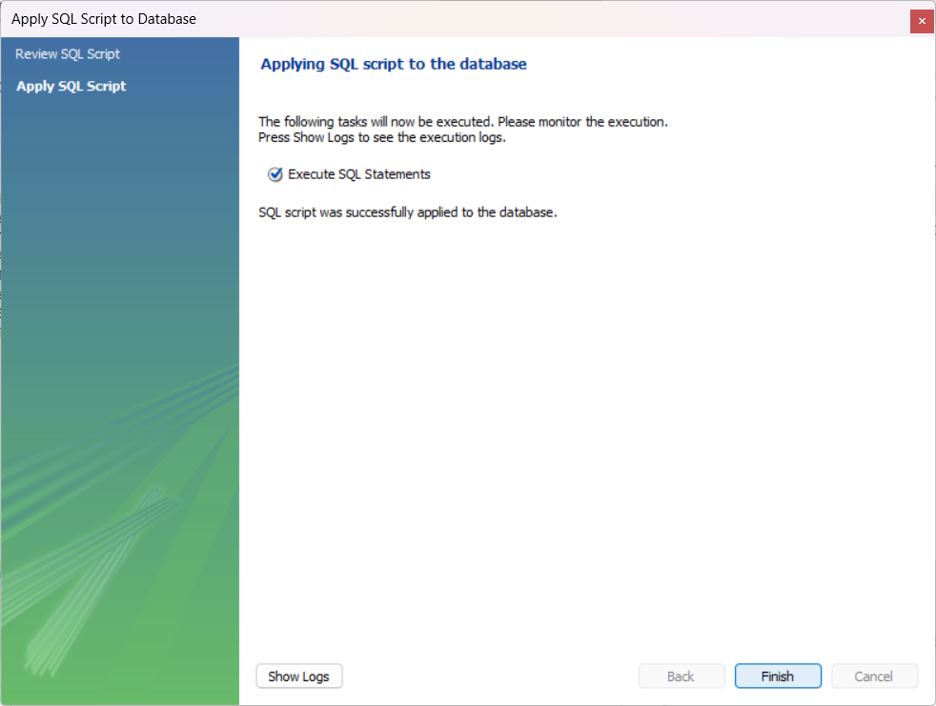

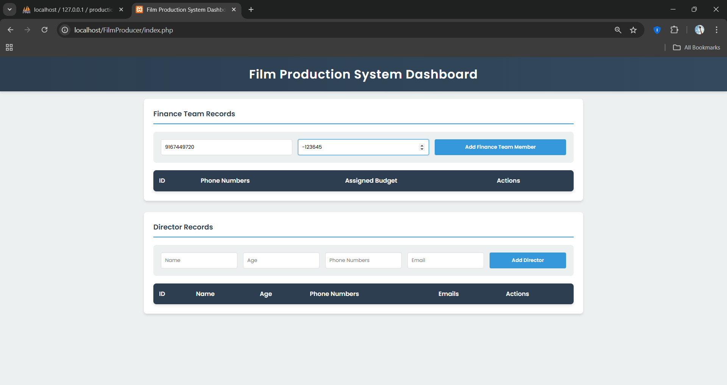

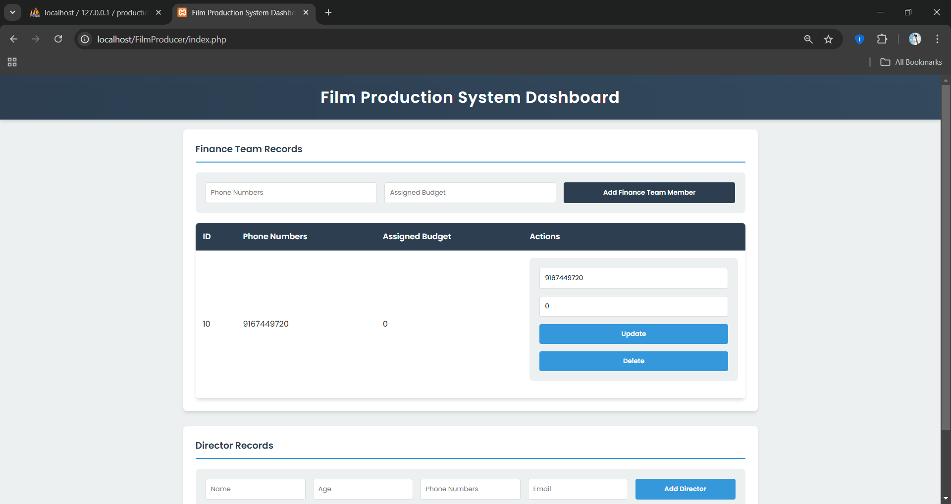

**AFTER_UPDATE Trigger**

CREATE DEFINER=`root`@`localhost` TRIGGER `production_db`.`finance_team_AFTER_UPDATE` AFTER UPDATE ON `finance_team` FOR EACH ROW

BEGIN

INSERT INTO finance_update

VALUES ( OLD.assigned_budget,NEW.assigned_budget,OLD.fi_phno,NEW.fi_phno);

END

